PSYCHOSYNTHESIS AT SCHOOL 1964-1981

The First Experiment

Isabelle C. Küng

WHAT IT TOOK TO PROCEED FROM AN ORDINARY SCHOOL TO AN EXTRA-ORDINARY SCHOOL WHERE THE ART OF LIVING IN HARMONY WITH ONESELF IS PART OF THE CURRICULUM

SUMMING UP

Dorette Andrée Faillettaz (previously Küng by marriage), was the founder of Institut Bleu Léman, a privately owned international boarding school for girls and young women 10 to 20 years of age. She was eager to provide good instruction to her pupils, who stayed an average of one or two years in the school, away from their families. It was important to her that her pupils be successful when sitting for the examinations (mainly CEEB, Cambridge “O”, “A” Levels, “First Certificate, and Alliance Française): this is why they attended Bleu-Léman. But she thought: “What is the point of being brilliant in academic studies, and yet live a miserable personal and inner life, tossed like a leaf in the wind?”. She was therefore eager to provide her pupils with means to educate themselves - that is, to awaken the inner teacher, discover their inner freedom and learn to use it with discernment, so as
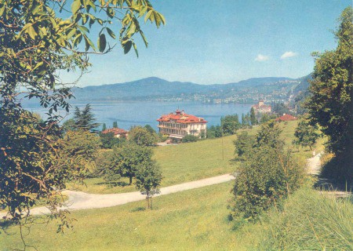

to be able to face the vicissitudes of Life with a “sportive, joyous and fair-play attitude”. This ideal meant that she had to turn her ordinary school into an extra-ordinary school… helping the gifted to blossom as humans, but in such a way as to avoid the pitfalls of excellence, no matter how desirable excellence certainly may be in matters of self-esteem and motor-force!

This article and these pictures are about how she achieved her first goal with the cooperation of life circumstances, her family, and Dr. Roberto Assagioli.

However, before entering into the heart of this subject, it must be mentioned that she had many other projects. One, which she indeed carried out later, was to create a second international school, specializing in the arts of managing an upper-class household, including etiquette and “savoir-vivre” (good manners). But although I participated in setting it up, as my mother’s employee, that is not the subject of this article. Let it simply be mentioned that she named this second - parallel - creation: Institut Villa Pierrefeu (IVP) and that it was, and still is, situated in Glion above Montreux. It may be relevant to mention, for it throws a complementary light on the present topic, that as regards IVP, she considered that executing outer action (like managing a household) in a harmonious way necessarily reflects at least as long as it lasts on the personality and character of the one who masters it. And that’s how it works for the great majority!

Yes, looking back I can today say that this personality-centered approach, relying on outer action, namely: knowing how to do, with the hope of influencing the inner core (thus becoming ‘that’ at least on the level of appearances), does make sense to a certain point. Indeed, it may, when non-harmful knowhow is imparted, add value, but on the ground of volatile personality matters. In his book The Act of Will, where the psychological laws that govern the psychic metabolism are exposed, Assagioli addressed this issue. Though the personality-centered way of handling matters may indeed prepare the ground, it certainly does not replace the more specific approach consisting in focusing on learning the means of inner action. Here, you understand who you are by experiencing being-ness and build yourself a harmonious character to be able to exercise in a comprehensive and dispassionate manner the skills that must be learned to work in a given field of action. That might be managing your own life, or your relations to the “other” (the manifold outer worlds that mirror our various inner worlds), or managing a household or a business. This includes taking morally appropriate risks.

Introduction: portrait of an Idealist!

Dorette Andrée Faillettaz was born in Vevey, Switzerland, in 1911 to a journalist mother and a telegraphist father. She was the third of five daughters. She went to school there and was therefore directly exposed to the pros and cons of the educational system of her time (Zeitgeist). This, and her personal disposition to “live life more abundantly,” induced her to rethink the “system” again, and again, and yet again!

Her main dream was to devote her life to bringing to the awareness of educators that education is life’s means for revealing and bringing to blossom the LOVE which sub-stands - that is under-stands (supports) - and in-spires; thus breathes ALL THAT IS into existence.

    - She considered that investing one’s best attention and means to this approach was one of the most efficient manners of creating the appropriate conditions to ensure meaningful success in Life, and have the opportunity to bypass its contrary. She resented meaningless success as being the cause of these awfully time-consuming small and big conflicts that pollute everyday life and postpone everyone’s ability to find their own true Self - the Being they feel they really are - and live a harmonious life worth living.

    - She found, the hard way, that instruction - rather than fostering the process of blossoming life’s essential qualities which everyone, without exception, is born with - is more often (mis)used to suffocate it. This rivalry (and confusion) between education and instruction caused her great inner pain… and probably fueled her passion to reconcile them! She held instruction, as well as education, in great esteem, considering them to symbolically be like the two hands needed to work.

    - She realized that it is a prerequisite to acknowledge the qualities inherent in the innermost of a person’s heart, and then provide her with the adequate means that help bring them to the fore (educere) so that these qualities may find expression in everyday life events. Everyday life is the field par excellence where the inner qualities (spiritual knowhow!) can truly serve in the form of
      - pacifying and dynamic attitudes,
      - harmonious relations to others (humans and creation), and
      - the ability to transmute conflicts and tensions knowingly, rather than eliminate them hastily or nastily, one way or the other. This implies accepting that tensions are necessary, precisely to exercise this ‘transmuting competency’ which is the hallmark of a conscious human being.

    - As regards point 3c, she had seen that transmutation of conflicts, even if it takes more time and attention, is far more gratifying, and lasting, than ruthless elimination (like wars or other means to get rid of living forms, obstacles or problems). Everyone knows that suppression only serves to breed the ‘crisis-causing factor’ underground and empower it. Who needs, so as to remain “on the move” and awake, to create more enemies and tensions than one already has? Thus the old elimination-reflex is to be replaced by the reflex-to-transmute (or sublimate). In this she was a forerunner, for only now has humanity begun to acknowledge that this reorientation of “the direction of the vital interest” (replace elimination with transmutation) is a major issue for human survival.

    - Finally, she had also recognized that WILL is necessarily the energy fueling LOVE, and that those who just followed their attractions, mistaking them for love, actually ended up being addicted to them, living in the illusion of not being addicted to them. The personality-ego is most resourceful when it comes to justifying the opposite of what is obvious to the intuition and to the spiritual Ego… She noticed that these people ferociously opposed the idea of WILL being the (secret) seed of LOVE; they most ably defended the thesis that only ‘spontaneous’ feelings could be sincere. Therefore, from their point of view, the proposition that “to will-to-love is the key to true LOVE and essential freedom” was just a make-believe strategy. However, they did see LOVE as the heart of truth… She wrestled with this for many years. And although the latter position did make sense to her, especially in her younger years, Life slowly brought her to value the benefits that stand behind WILL-inspired-LOVE. Undoubtedly, the delusions and (literally) dis-enchantments one inevitably meets each time a new light is cast on a relationship also helped her shift her opinion. One might meet these in a personal relation, in the family, in the professional sphere or in social Life, or just as regards material things. She got to appreciate, in matters of human relations, the wonderful sense of liberation love brings when it is nurtured by will. That is when it is neither adulterated by possessiveness nor held a prisoner by selfishness. This is, ultimately, the more subtle form into which human, personal and possessive love transmutes itself… in the course of Time.

    - Of course misinterpretation of this point of view, as regards the genuine ‘sincerity’ of will-inspired-love, sometimes led her to misunderstand others and be misunderstood… but her quest was fundamentally honest, and somehow fearless too, and Life (maybe therefore?) always got her back on track!

It does so for all of us. Sometimes in disguise!

The facts – how the ‘transmutation’ from ordinary to extra-ordinary occurred

Thus by 1954 - please note the year - Life circumstances finally made it happen that she, as a divorced mother of two girls, a 10-year-old and a 12-year-old (me, Isabelle Clotilde and my elder sister, Viviane Elisabeth), could concretize the dream of her life. That was to help the younger generations of women, the future mothers of the humanity in the becoming, to understand the essence of education, LOVE being its perfume and WILL (of course spiritual) constituting its hidden roots.
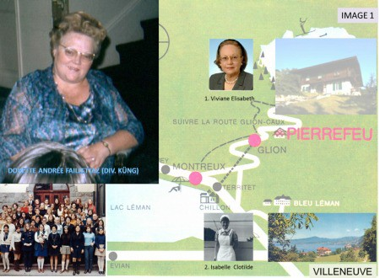

That year she founded - with nothing to begin with except providential help - a privately owned international boarding school for girls.

Her dream was coming true….

But soon she found that in order to convey her realization - or, in order to transmit her flame to her pupils - words and good intentions, no matter how good, were certainly most useful, but ultimately also would lead to dependence…. Her pupils loved her and appreciated her inspiring guidance, but they depended on it. She was quite flattered, but vanity was not her cup of tea! She clearly saw that this affectionate dependency was the opposite of the core of what she wanted to convey to her pupils, namely that LOVE sets you free.… the opposite of what the majority warns us from, yet longs for, in matters of inter-individual relations! With dire consequences, and unending misunderstandings.… How could she, she was asking herself, convey the glorious idea hidden behind the kaleidoscope of illusions that keep said majority in thrall?

So she reflected and searched for appropriate tools that would address the issue from an angle as neutral, but also as dynamic and pragmatic, as possible. They had to be psychological tools because the student body of the school were from a variety of religious backgrounds, including agnostics (believers without denomination) and atheists (believers in no-thing); therefore, no religion could be even mentioned - despite the fact that each approach to the spiritual, inner life does provide some tools. They had to be psychological tools, because given that the causative factor of any outer action and behavior lies in the psyche, it is on the inner, spiritual side of our life, that the (existential) issues need to be addressed - not with “beliefs” (not even scientific dogmas!), but simply through right use of the mental competencies that happen to be the tools for working with the psyche. Paraphrasing the preamble of the constituting act of UNESCO, she knew that it is these competencies, namely thinking, feeling, intuiting, willing, desiring, imagining, that tailor all the actions we do: be it war or peace. She knew that therefore it is by the understanding and the right use of these competencies that we can re-create and transform our predispositions, our gifts, our potential… and keep in thrall what keeps us in thrall! This knowledge had been stated in the mid-40s… and it was stressed again in the Universal Declaration of Human Rights… so why had no method appeared so far to turn these vital theoretical statements of facts into practical means of fostering harmony amongst people and nations?

So Dorette Faillettaz felt it was imperative to find those tools that could pave the way to this vision/understanding she had: namely, the relation between EDUCATION, LOVE, and WILL: the core of human dignity! She was also on the look-out for methods that trigger psychic or physical side effects!!! She instinctively felt that “right motive is oft deflected by wrong method” (old oriental wisdom) and really wished to find the right method.

She found and tried a few… and we helped in testing one I remember, a “reflex-conditioning method!”. She gave it up when the student that had benefited from that method switched from crying day and night to laughing all the time!

Where was the method that would be both efficient and harmless? If it existed!

In the meantime, she used the one she knew best: talking her pupils into loving understanding, tolerance, international thinking (for some time IBL became an associated school of UNESCO), and into keeping studying so as to be successful in the official examinations the team of teachers prepared them for; for after all, if this aim was achieved, the parents who invested a lot for that, would be satisfied!

After four years building the good reputation of her school, Life circumstances again popped up with a hint!

It happened that in 1960 an acquaintance asked Dorette Faillettaz whether she could host for a week an international meeting of psychologists and educators during the school holidays. She immediately sensed the opportunity to discover new avenues to respond to her quest and replied with an enthusiastic “yes.” Then she asked, “But are they competent and responsible people?” She remembered the episode induced by the ‘reflex-conditioning method’ where a student had gone from unceasing tears to laughing fits.

And so on August 24, 1960, Dr. Roberto Assagioli, his wife Nella, and his secretary Ida Palombi arrived in Solange van Berchem’s car, and during a few days people like Dr. Jean Guilhot (founder of the first Psychosynthesis center in Paris), Robert Desoille (directed daydream), François de Jessé, Paul Diel (motivation psychology), Dr. Mastropaolo, Dr. Triant Triantafyllou (Ministry of education in Athens), Dr. François Ledoux (Méthode Vittoz), Edouard Berge, and Lanfranchi joined Assagioli and his vice-president Gabriello Cirinei for the talks, while the public, like Mlles. Suzanne Nouvion, Jacqueline de Chevron-Villette (antroposynthèse), Giuliana Contini, Paolo Bassano, and others participated to the most animated
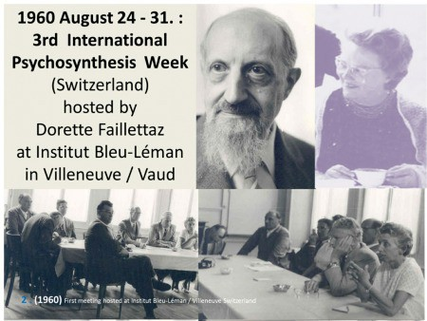

debates….
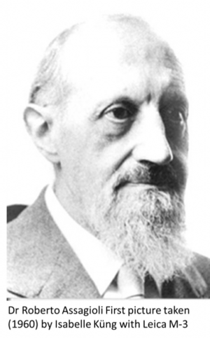

As for me, I was just allowed to listen; and as I had a brand new Leica, my mother asked me to take a picture of Assagioli.

Dorette Faillettaz, was really interested by the variety of the methods presented and the inclusive attitude of Assagioli, especially as it was an attitude of spiritual inclusiveness, not uniformity. No doubt his non-offensive, efficient, and user-friendly method of self-actualization and realization of the Self (as Assagioli would ‘formulate it’ in the Manual he would publish five years later), or self-education, was what she had been looking for.

She wrote to Assagioli to ask him whether he would give talks to the Fédération Suisse des Ecoles Privées (FSEP) and conferences to her pupils too. On Jan 28, 1961, Assagioli declined in the following manner, worth quoting for it shows to the extent (and not without a touch of humor) he would make the difference, in the minutest details, between himself and his personality (body and emotional/mental equipment):

“As to your invitation to give talks to the Federation of Directors of Private Institutes and to your pupils, it is very attractive, but I must remind myself that my body is 73 years old and I must spare it as much as possible! I cannot impose on it additional activities and travels, on top of those that I have the obligation to inflict on it to the limits of its strength due to numerous commitments which I have already taken for the next months (articles to various magazines, revision of other writings, a series of conferences in Florence, etc.). I therefore beg you to forgive me, or rather, to excuse it!” [Translated by the author from French, a language Assagioli spoke fluently]

In 1961 my mother, Dorette Andrée Faillettaz, hosted another International Week of Psychosynthesis, this one from Sept. 1 to 7, at Institut Bleu-Léman in Villeneuve (Switzerland). Assagioli and his team arrived directly from Vienna, where he had given a key address at the Congress of Psychotherapy: “Psychosynthesis and Existential Psychotherapy”. Therein he emphasizes some of the most important principles of his method, namely
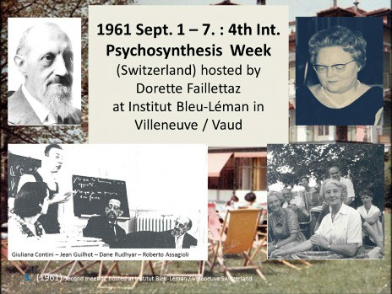

“1. To proceed from within, that is from the self of the patient; 2. To take the process of individual development and growth into due consideration; 3. To search for the meaning of Life; 4. Recognition of the higher values, and 5. Emphasis upon the future.”

During the 1961 Week at Bleu Léman, many of the same attendants
as in 1960 were joined by others, like Florence Garrigue, Tilla Grenier, Ludovica Hainisch-Marchet, and Hubert Cuypers, Dr. Robert Gérard, Ignace Lepp, Dane Rudhyar, and Dr. Paul Tournier. Francesca Piani Boesch wrote a noteworthy summary of this week.

As I recall, the main subject of discussions was aimed at understanding that the spiritual Self or Reality is an experience (it escapes “limited and limitative” definitions). Too often searchers, earnest searchers, interpret spiritual realities in terms of personality matters…

Allow me a precision: to use personality-terminology to describe spiritual, that is, invisible, realities like thoughts was acceptable in Ancient Greece. Then this approach aimed at bringing the spiritual realities, that is the energies at work in the universe, was brought down to earth, thus within the reach of understanding of the humanity of that Epoch. Presenting these more subtle, intense and inner energies as having a somewhat human form “out there” (e.g., Athena, Goddess of culture in times of peace) enabled the population to identify to these ‘invisible energies,’ and induced them to personify them, feel and incarnate their characteristics and act them out: it was a means to help the people develop a distinct personality. At that time, this approach was appropriate, because the emphasis was - and needed to be - personality-centered. Today (21st century) the emphasis has been on altruism and awareness of the Group and various groups… a realization that is only possible if and when the personality-centered stage has been duly assimilated, which implies that the ‘invisible’ energies have been qualified and are acted out without harming.

In any case, it was not easy during the debates to make it understandable that the personal self is but the reflection of the transpersonal Self, and therefore has no reality of its own (as depicted by R.A.’s “egg” diagram), save that of serving as training tool and at the same time ground for the mental unit to ‘gain’ the spiritual competencies needed to tailor, wave-in and manage its ‘relative unrealities,’ so as to testify or rather reflect the inner Reality outwardly, and also work out the vaster ‘vision’ this Reality conveys. Big discussions! Nourished further by the “cosmic vision of Père P. Teilhard de Chardin”, presented by Hubert Cuypers! He emphasized the need for a blossoming of the psychic (spiritual) energies, thus converging perfectly with Assagioli’s point of view that considers Psychosynthesis as the “Science of psychic (spiritual) energies”. But words are only the ambassadors of the mental dimension where time is not, therefore they fly… and what matters, once the words have played their inspiring role, is training: Yes, training is that which accomplishes! And this - both words and tools - was what the director and founder of Institut Bleu-Léman was looking for, for her pupils.

By now Dorette Faillettaz definitely wanted to know more. She traveled, with me, down to Capolona to visit the Assagioli-Ciapettis. We stayed at La Nussa, visited the hill and grounds where later Villa Ilario would be built. We also visited La Verna Monastery where Saint Francis had resided. This gives me the opportunity to quote the passage worth pondering upon, about Assagioli, written in the 30s, by Frank Vanderlip in his book What Next in Europe (pp. 152-153):
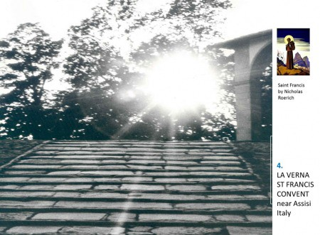

“I met in Florence a man who left me thinking of him, after a few days of acquaintance, as something of a modern Saint Francis. He has none of the accoutrement of that Saintly Monk, but I believe that he has a good deal of the spirit that made Saint Francis live. There seemed to me to burn in this man the pure flame of a love of justice and
humanity. Roberto Assagioli is his name. A talk with him on a moonlight balcony overlooking the Arno was one of the incidents I shall best remember in this whole European trip. It was in deep contrast with the bitter comment on conditions and Life I heard from so many people in other countries. He seemed to have a calm and serene understanding of the causes of the troubles of the world and a sensible apprehension of where materialism is leading the world. He expressed such a cheerful hopefulness that a better road is at hand if the world will but take it. If I am not mistaken this man has the sort of human goodness that has characterized other men who have initiated great moral movements which had small beginnings. If I were asked to indicate precisely what he has accomplished or is proposing to accomplish, any statement that I could make would not be expressive: nevertheless, I was impressed”. (Emphases added.)

We also were impressed by our stay at La Nussa. And after some time, my mother and Assagioli made a decision based on several considerations. He could not come in person to teach the pupils of Institut Bleu Léman this method which she now considered as worth including into the curriculum. Also, she had to stay there to manage the school. By now I too was interested and recognized that I certainly needed to take that training for myself to begin with. Since my sister was an honor student at UCLA, well… “if” possible, I would be sent to Florence to learn the method. After six month’s weekly sessions and attending Assagioli’s weekly courses to the young, and conferences, I would begin practicing a few exercises with the pupils of the school (to start)….

From then on (and until 1974), every year I spent a month in Florence, residing as a guest at Via San Domenico 14 (now headquarters of the Società Italiana di Psicosintesi Terapeutica or SIPT), learning what I could and reporting about my experiences of teaching the method.

In 1965 Dorette Faillettaz hosted yet another International Psychosynthesis meeting. It was the seventh (according to the chronology of the Istituto, before Ida rearranged it).
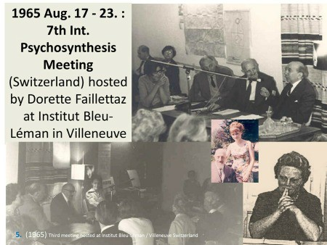

There were more attendees - clearly the next conferences would have to be held at a larger place. Nevertheless the atmosphere was as usual most friendly, and the talks most interesting, with speakers from North and South America, England, France, Germany, India, and Italy. Participants were numerous. Assagioli gave three addresses: 1. on cooperation (1965 being the “year of cooperation”), 2. various ways of educating the particularly gifted, and 3. Freud, Jung and Psychosynthesis. The French psychiatrist, Dr. Henri Baruk, spoke about “La Chitamnie”, meaning, if my memory is correct: establishing more humane relations with patients in psychiatric asylums by awakening their sense of trust and of “justness” (TZEDEK in Hebrew).

My training went on, Gabriello Cirinei spent a summer with us to talk to our teachers on education and to translate, with me, from the Italian to the French a few selected lessons of Assagioli. Year in, year out, I worked most of the time at the school. I also taught etiquette and flower arrangements. But mostly I taught Psychosynthesis - now more specifically, and to all the pupils. But remember that we were in the 60s, in Europe, in pretty conservative Switzerland, and I was only a young adult. There was an advantage speaking the same language as the pupils, but it meant also that I could not take their acceptance for granted. I therefore decided to designate the imparted subject-matter by the terms:
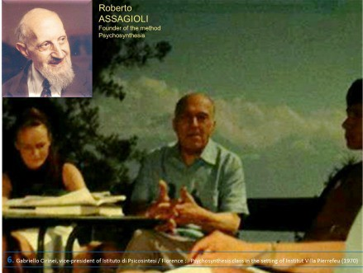

- the ‘anatomy and physiology’ of the healthy psyche, and
- the techniques and adequate exercises to harmonize the personality’s potential.

With this wording, the pupils instantly understood that “Psychosynthesis classes” with Madame Isabelle referred to familiar concepts: “I, me and myself - be happy!”.
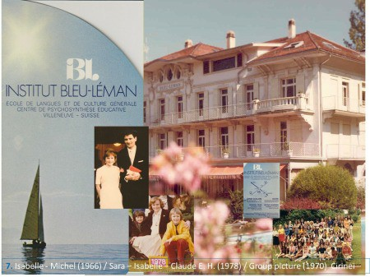

And in 1966 I got married. In 1970 we bought Bleu-Léman, where I went on teaching Assagioli’s method seven hours per week to classes of six pupils each, administer the school, and also became mother of two: Claude-Emanuel H. and Sara-Gabrielle I.

Conclusion

Dorette Faillettaz’s quest had been completed. From dream it became a reality. A means of giving to the pupils a non-offensive psychological
tool to educate their character was integrated into the curriculum of the school, transmuting it from an “ordinary” to an “extra-ordinary” school, one might say! She wanted it, Assagioli responded with the appropriate means, and I was fortunate enough to be helped to “do the job”…. Thus learn!

We owe much gratitude to Dorette Faillettaz for her open mind and courage to innovate in a wise manner, in line with her motto “Confiance – Ethique – Réalisation”: Trust – Ethics – Accomplishment

She knew the motor-value of words, a point Assagioli describes in his article of (1967/8): The Technique of Evocative Words (available on line at AAP).

As you see, it is actually easy to turn an ordinary school into an extra-ordinary school, simply by including within the normal program of instruction, free of charge (as was the case in our school in the school year), the means to educate oneself to live in harmony with oneself, and by reflex-action, with others.
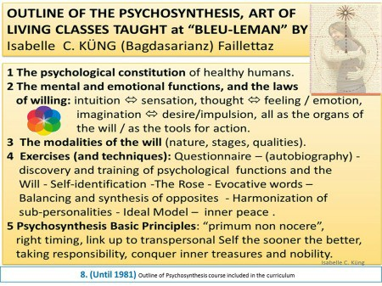

Dr. Assagioli too followed and supported this experiment with attention: it was the first time that his method of self-actualization and realization of the Self was put to the test (for 17 years), and became part of the curriculum of a privately owned international school: Institut Bleu- Léman in Villeneuve, Switzerland.

I am most indebted to him for having made this possible by his generous sharing of his competencies and his trust in me and all of us involved in the experiment, especially Gabriello Cirinei, Ida Palombi and lovely Nella who mothered me.

Additional information

In a parallel development, my sister Viviane, who came back from the US and also got married, bought Villa Pierrefeu in Glion (www.ivpworld.com) the model finishing school Dorette Faillettaz had also founded as the accomplishment of another of her dreams. It is still operating and Viviane gave it a wider dimension!

And Institut Bleu-Léman? Well, when the building was sold in 1981 by its owners (we only owned the school) I turned the school itself into a “bureau at the service of education”. And for a while the Swiss Red Cross rented the place to test an ideal formula to house refugees, asylum seekers…. Then the building was transformed by its new owners (an insurance company) into apartments for sale… with a beautiful view over Lake Léman and the Castle of Chillon.

And I now live in Geneva, busy with cultural matters and writing.

Source: AAP Psychosynthesis Quarterly – December 2016

